Ethan Allen Round Chair Top Glass Dining Set

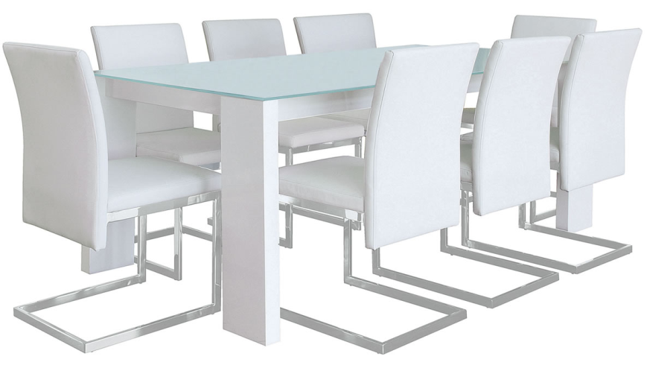

|  |
| --- |
| **DESCRIPTION** |
| Ethan Allen introduces stylish round balanced chairs which is perfect for durable surrounding. Two long table legs makes it easy for people sitting to adjust their legs inside the table and the chemical glass which is used above the table is very strong and build to hold weights without getting cracked. |

|  |  |  |
| --- | --- | --- |
| **Price** | **1800$** | |
| **Dimensions** | **Table H** x **W** x **L** | **55in x 45in x 57in** |
| **Chairs H** x **W** x **L** | **45in x 30in x 33in** |
| **Features** | **The chairs which have soft form seat which is very comfortable and has round legs which enables chairs to adjust to the weight.** | |
| **Finished** | **White Platinum paint** | |
| **Available in** | **White and Off White** | |